Elementary Art Lesson Plan
Colorful Castle
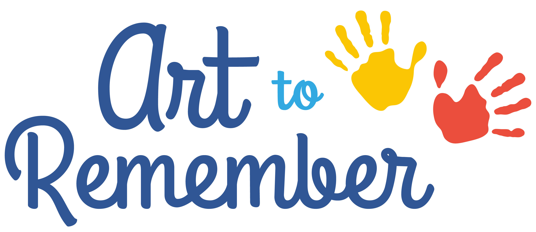
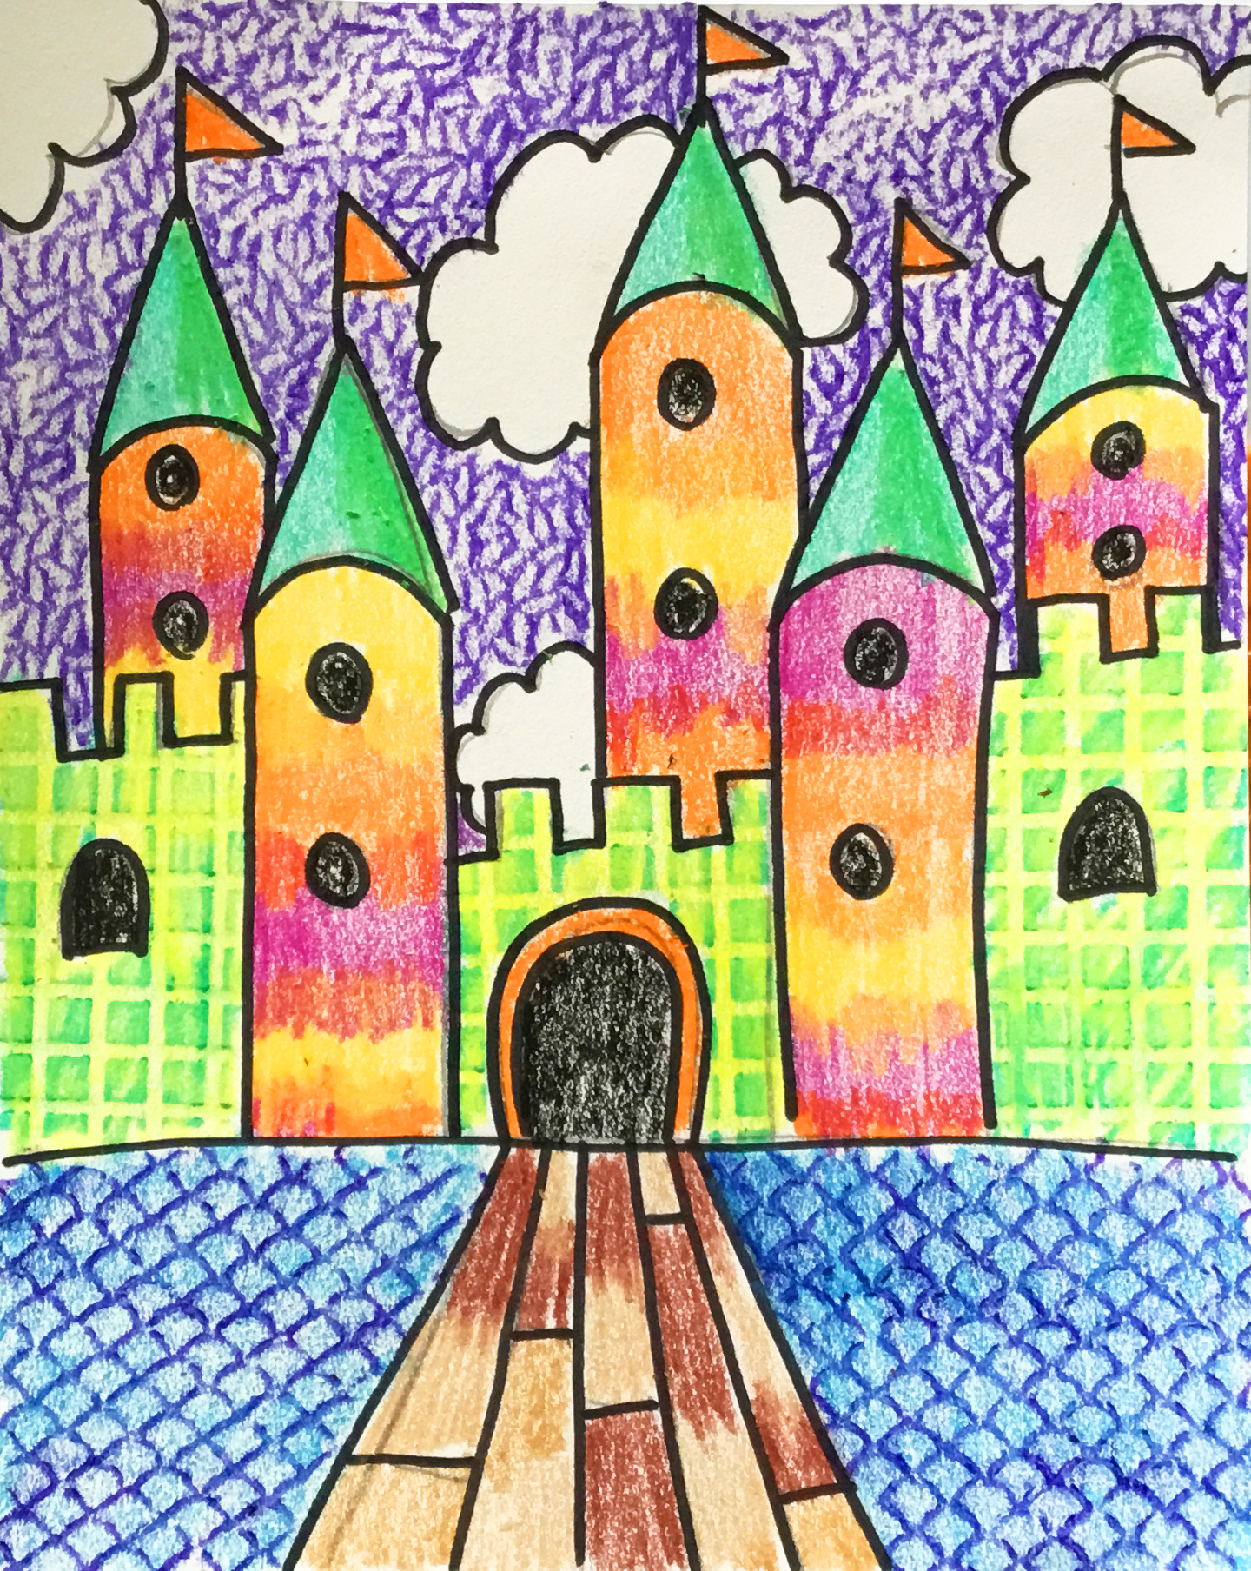

Finished Project!
National Standards for Visual Arts:
Anchor Standard #1. Generate and conceptualize artistic ideas and work.
Anchor Standard #2. Organize and develop artistic ideas and work.
Anchor Standard #3. Refine and complete artistic work.
Anchor Standard #10. Synthesize and relate knowledge and personal experiences to make art.
See more at: http://www.nationalartsstandards.org/content/national-core-arts-standards-anchor-standards#creating

Objective: Students will draw a castle. They will also learn two ways to color with crayons including blending and texture techniques.

Recommended for 2nd – 5th grade
Materials:
Provided by Art to Remember:
- Paper
Additional supplies:
- Pencil
- Permanent Marker
- Crayons
- Texture Plates

Open the Conversation:
A person who designs buildings is called an Architect. In this lesson we will all become Architects because we will be designing a castle. You will have the choice to use realistic or abstract colors on your drawing. We will also be using a couple of techniques while coloring this work of art with crayons. Blending is when you take two colors on top of each other to create a new color. We will also be using plates to create texture on our paper as well.

Step One:
Students will create a drawing of a castle using pencil. Then, outline with permanent markers.
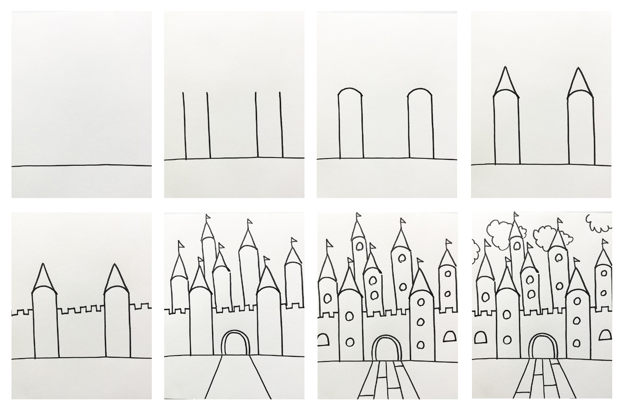

Step Two:

Students will color in portions of the castle with blending techniques.

Step Three:
Students will color in portions of the castle using texture plates.
